**Preserving the Integrity of Information Consumption**

|  |
| --- |
| **Mustafa Alfaouri** |
| Dept. of Computer Science |
| Montclair State University |
| Montclair, NJ 07043 |
| alfaourim1@montclair.edu |

|  |  |
| --- | --- |
|  |  |

**Abstract**

Fake news and its propagation have become a widespread issue in the past few years, so much so that the American government has called in the executives of tech companies to question how they have been preserving the integrity of the information that is spread on their platforms. Many researchers have analyzed how fake news is created and propagated throughout the internet. To push back against the decay of information integrity online, others have developed tools to detect fake news and make it apparent to the end-user that what they are reading has a certain bias or subjectivity or that the information may not be credible at all. Different approaches have been used to combat fake news. These methods range from manual verification conducted by small credible groups or a wide-scale effort to verify information as quickly as possible. Many have begun to automate the process by using Natural Language Processing, Machine Learning, and other techniques to extract information and run it against known good information to determine its legitimacy. While many of these methods are effective in their approaches to combating disinformation, the method that is presented as an alternative will give users a new perspective when viewing information online. It will provide some insight into other users who view that same article and their stances. The PropTool Browser Extension gives users an idea of how much propaganda other viewers consume and allows them to come up with their own conclusions based on that information. While the tool is not designed to detect propaganda, the information that it presents may help provide insight into how users may perceive misinformation.

**Introduction**

The internet has been around for consumer use for well over two decades now. Its age and the concept of freedom of information applying for much of the developed world, allowed us to enter the information age. Information has always had its way of getting around since the earliest days of human civilization. This began with messengers, and congregations in small towns and villages for much of history, it would take days or evens weeks for some information to go from one physical region to another. As technology developed, we developed new ways to relay information to others. Humans developed more efficient ways to print newspapers and were able to send information through telegrams over long distances before the days of the telephone. That transmission of information became faster over time. Towards the latter half of the twentieth century, the American Military began to exchange information through a series of connections that they referred to as networks. These networks became more decentralized and more reliable over time with the invention of TCP/IP which laid the foundation of the internet **[A 2016**].

In the early 2000s was a luxury that we would only use for short periods during the day on a computer that we would either own in our homes or be available in a public library. The home phone could not even be used at the same time we were browsing the internet since the internet utilized dial-up connection back then over a modem that ran on the technology like that of a phone’s connection. With the development of broadband and eventually fiber connections. The speed and efficiency of the internet increased dramatically. Information that took nearly a minute to load began to take only a few seconds. It only took a few short years for our phones to catch up in speed with the development of cellular connections and smartphones with computer-level hardware.

When unlimited data cellular plans became normalized, this enabled people from almost anywhere to always have access to the internet. Being able to do research, catch up on news, or connect with friends and family in a manner of seconds. At this point, communication with others all over the world is not an issue. Now how can we establish a secure way to ingest information online just like two parties establish encrypted channels to send information to each other? The key to doing this is devising a way to indicate if the information a user is viewing has integrity or not. Whether it is an article out of context or a tweet making a baseless claim. The obstacle that must be overcome is that the general population has been condition to simply read headlines or small posts to keep up with whatever events may be happening around them. The goal of tools that combat fake news should not just give the user insight into what they may be reading and whether it is true or not, but it should ideally compel them to maybe pique their interest in what they are reading and think 5more critically about it, something that is severely lacking today. Fake news is as old as humanity itself, but it never came to the point where some begin to refer to society as post-truth. The nature of fake news, how it can be detected, and how it can be spread must be explored to understand how tools are created to combat fake news and the various approaches these tools take to do so.

**Fake News**

In today’s world, people rely primarily on social media to keep up with what’s happening in the world, making it their primary news source. According to a study conducted as far back as 2005, the internet was the primary source of news for individuals between the ages of 18 to 34. A Reuters Institute report published in 2020 found that a significant percentage of social media users across multiple platforms consumed news from them. Facebook unsurprisingly has the highest percentage at 36 percent and the lowest was Twitter at 12 percent which is still many users although in the minority **[Vorhaus, 2020]**.

This set the stage for a significant amount of the American population to deviate themselves from reality and believe a good portion of the fake news or disinformation that began to appear on the feeds on whichever social media platform they use. The two most significant in this case would be Facebook and Twitter. Much of this came to light during the 2016 presidential election, where many users and possibly bots of foreign origin began to spread disinformation to pit one side of the American political spectrum against the other **[Frank, 2018].** The very programming of social media did not mitigate this issue in any way. The way Facebook and other platforms operate is that they would tailor a user’s experience to their preferences, essentially placing them into an echo chamber **[Suciu, 2019].** Making them believe that most people think like them and showing them content that further demonizes individuals on the other side of the spectrum or people who simply do not agree with them.

This political divide was shown again and perpetuated through social media and computational propaganda differently in the 2020 elections. In the middle of the pandemic, there was disinformation spreading about COVID-19 or Coronavirus ranging from its nature to its effects. When the Vaccine came out in recent months, there was more disinformation spreading about the vaccine and how it could potentially harm people, this disinformation not only affected the views of people in the United States but people all over the world. Spreading fake news has proven beneficial in pushing agendas but it has also proven to benefit some financially. It was reported by NBC that young people in their teens from Macedonia were able to make tens of thousands of dollars on penny-per-click advertising during the 2016 American Presidential election. These teenagers were able to surpass their parents in income and drive up the average income of the town they resided in **[Smith and Banic, 2016].**

What makes this more concerning is that on average people have a 54% to 58% chance of distinguishing true information from false information **[Rubin 2010]**. People generally expect that whatever they read that is categorized as the news will always be true, so they are already lowering their guard mentally before reading anything, to begin with. Concepts like, confirmation bias (which plays a huge role, especially on social media platforms), selective exposure, and the bandwagon effect are some of the main drivers that allows fake news to spread so easily and what allows people to continue to believe in it **[Zhou, et al 2020]**.

**The Propagation of Fake News**

What makes disinformation so dangerous is not the simple fact that it exists, it is that spreads at an alarming rate as opposed to legitimate information. Researchers lay out the stages of how information spreads and discuss several theories of how fake news propagates and how it affects a user’s view of a given topic. One form of propagation is the unintentional spread of disinformation which usually happens when a non-malicious user comes across a post and believes it at face value, this user then likes, comments, or reshares the post spreading the post to their friends and followers, this same process repeats itself for some time allowing the post to gain traction and start trending. There are other reasons that this user may propagate the post, they may do it for social acceptance and may continue to do so if it reaffirms their previously held beliefs and keeps them within an echo chamber of people that agree with them. on the malicious end, we have users that spread this information for their benefit, financial or otherwise. Like many other computing processes, the spreading of fake news has also become automated with the use of online bots that can spread fake news far faster than any malicious user can. A diagram of Fake News Propagation modeled by some researchers can be seen here **[Zhou, et al 2020].**

The ways that fake news is propagated can be classified into two levels: the individual level and the social level. On the individual level, fake news can spread largely in part by the fact that many people cannot distinguish between true and false information. There was a study conducted with 1684 adults from the UK. These individuals were shown 3 real articles and 3 fake ones. The study concluded that only 4% of the group were able to successfully determine the legitimacy of the articles shown to them **[YouGov 2017**]. Based on this, it needs to be assumed that a great portion of the population cannot vet information when left to their own devices. This would demonstrate the need for tools that combat fake news.

With the way social media is tailored to a user, it causes the echo chamber to affect, only showing a user content that they agree with **[Jamieson and Cappella 2008]**. A user would be further compelled to spread and interact with this information but not only because they agree with it but because those, they seek to be accepted by agreement with that information too. This is how information is spread on the social level whether that information would be real or not. Social media platforms are open about how their platform is tailored to each user. However, this has its consequences as we just discussed. This has also played a role in polarizing the American populace, especially in the political context. It may lead users to read content that may further demonize people that do not agree with or oppose their views **[Lang 2019]**.

**Consequences**

With all these fake stories spreading and the reports coming out that countless false posts accumulate up to views within the billions, what are the consequences of all this information spreading? In the past five years, more and more people in the United States and around the world have been disputing reality itself. Even sites and outlets once considered credible is now being dismissed as unfairly biased or outright false. There have always been small, fringe groups that went against what was generally acceptable and credible information. With the rise of social media, many of these groups began to grow but were still not that much of a problem and were left to their own devices.

These groups included anti-vaxxers and flat-earthers, who outright denied scientific facts that had been proven time and time again with solid proof. With the pandemic that hit the world by surprise at the end of 2019 into the beginning of 2020, more of the general populace began to drift away from reality and misinformation began to dethrone the credible institutions responsible for addressing and solving the plight that was and is the Coronavirus Pandemic. Increasingly more people would openly express their doubts about the virus’s existence, the vaccine’s efficacy, and whether masks were necessary.

Before major events like COVID-19, fake news took precedent years before. In 2008 there was a false report about a company that owned United airlines going bankrupt that caused its stock to drop causing the stock to plummet more than 75% and the stock not recovering for 6 days even after the report was falsified. Other examples we have are conspiracy theories like pizza gate causing an armed individual to attack a business. Other examples include the 2016 general election in which information about the two presidential candidates propagated at alarming levels, further polarizing the American population. Other information included posts about natural disasters and other prominent figures in politics worldwide **[Hui et al 2020].**

**Methods of Detection**

With the overload of information on social media and the internet., it is evident that the tech giants such as Facebook and others will not do enough to ensure their users will have a propaganda-free experience in the online world. This begs the question as to whether there is any action users can take to mitigate or outright prevent false information to come on their feed and go unnoticed. Luckily, there are some efforts to help users distinguish between disinformation and credible information online. There are various methods used to detect fake news. One of the most well-known methods is known by many as fact-checking. A term is now known by many which was fervently used by the media in the days of the Trump presidency. Fact-checking is the process of verifying information that has not been fully confirmed against known facts to determine whether that information is true or false.

The two methods of manual fact-checking are known as the following: expert-based and crowdsourced. Expert-based fact-checking is conducted by a small group of people with high credibility that verify the information. Expert-based fact-checking platforms include PolitiFact, the Washington Post fact-checker, FactCheck, and others. Each one of these fact-checking sites analyzes different types of content and labels them in different ways. For example, PolitiFact analyzes Statements made that are relevant to American Politics, it then labels these statements as True, Mostly True, Half True, Mostly False, False, or Pants on Fire. The levels of legitimacy in which they rank information are self-explanatory in this regard. Below we can see a chart a scorecard PolitiFact has created for Donald Trump, giving an overview of how true the statements he makes are based on their fact-checking of his statements **[Zhou et al 2020]**:

Crowdsourced fact-checking is a much larger collective of individuals that are undergoing the task of verifying information. The only problem with crowd-sourced fact-checking is that it cannot be as thoroughly vetted as expert-based fact-checking. Since it is a large group of people verifying the information as opposed to a vetted group of a few individuals. While crowdsourced fact-checked, is not as reliable, the process can be conducted much faster since it is a much larger collective verifying information. This will become exceedingly difficult over time as the numbers of people that conduct fact-checking increase over time. People who utilize crowd-sourced fact-checking must ensure that they add an extra step of filtering the information they extract to ensure that whatever crowdsourced fact-checked information they are viewing is credible. If this is not done, then it would defeat the purpose of verifying information integrity in the first place. An example of a crowd-sourced platform is called Fiskkit. This platform aggregates tags that users add to describe the content of articles shown here **[Zhou et al 2020]**:

These tags give insight provided by these users who conduct fact-checking and demonstrate what else can be found in an article other than statements being outright true and false. Someone may tag a statement that may sound very convincing but may end up being fallacious. A label for fallacy can be found in the diagram above, although none were detected in the article analyzed for the results in the example.

**Methods of detection: Automated**

Automatic fact-checking is a useful method to assess the credibility of information since manual fact-checking can take some time, even with the scalability of crowdsourcing, have an automated process can prove to cut the processing time down by quite a bit. Automatic fact-checking utilizes concepts like machine learning and Natural Language Processing to detect fake news. There are two stages of automatic fact-checking presented by researchers, it is split into two phases. Fact extraction which entails extracting hard facts and fact-checking which is where the fact-checking occurs shown here **[Zhou et al 2020]**:

Some tools used to combat fake news are typically ones that utilize a knowledge base from fact-checkers to analyze the information viewed on a page. Natural Language Processing is used to provide an in-depth analysis of fake news detection and subsets of detection. The methods of NLP include preprocessing, machine learning models, non-neural networks, and neural networks. Preprocessing identifies the frequency of certain words, weighing them and categorizing them. Machine Learning further assists in identifying certain aspects of fake news detection subsets, such as style and sentiment analysis. Non-neural and neural network modeling helps in the categorization and weighing of certain factors in analysis and is widely used as a base model for natural language processing to go off **[Oshikawa et al 2020]**. Style-based detection relies on Machine Learning to analyze the style of the text in-depth, identifying the structures of fake news articles. This gives more insight into the intention of the information being analyzed, what is the goal of the article or post? Is it meant to give people beneficial information or mislead them altogether?

**Tools Used to Detect Disinformation**

Hoaxy is an online platform that enables users to see the diffusion of information on Twitter. It is easy to use and allows you to export CSV files based on whatever article you input into its search bar. I inputted a Reuters article provided as a suggestion from Hoaxy that was released the same day I analyzed it and here was the result**[Lynch 2021]**:

There is not much diffusion since the article is less than a day old, but it showsthe source in the middle being Reuters and the users sharing the article branching out from the source. The visualization is user-friendly and gives people an appealing visualization information diffusion over Twitter. This would look much more branched out than this if it was a more viral article and given more time to spread.

Botslayer is a tool that can be used to detect suspicious activity on Twitter. It expands upon what Hoaxy can do and has an optional integration within bot slayer. It allows a user to track how information is manipulated on the platform with a dashboard to track accounts that may be running disinformation campaigns and the like through a dashboard. It also provides visualizations of how the information a user is tracking spreads throughout Twitter. Users were able to track terrorist propaganda and Russian botnets with the tool. Here is a visualization example provided by the developers showing how bot slayer visualizes tracks a coordinated campaign here **[Hui et al 2020]**:

This tool is highly configurable and open source. While this tool is useful, it is only ideal for professionals like Journalists, Researchers, and other organizations that this may be relevant to. It is not meant for the everyday user who reads a few headlines or a few social media posts daily. The other limitation is that it is only meant for Twitter and no other platforms.

Browser extensions such as TrustServista and Stopaganda Plus provide an effective solution to weeding out propaganda. TrustServista provides a content quality report that displays percentages in certain areas to give users an idea of the nature of the content they are reading **[Lans, 2021]**. Is it being taken out of context? Is the article biased? Here is an example of a report:

Stopaganda plus takes a different approach, it utilizes the information of a fact-checking site and creates tags for article links that indicate their accuracy and their bias. It is a very convenient and quick way to give users an idea of what they are reading. The accuracy ranges from very low to very high. The bias categorizations include middle left, middle right, and pro-science. Here is how this extension is being used while viewing a NASA article:

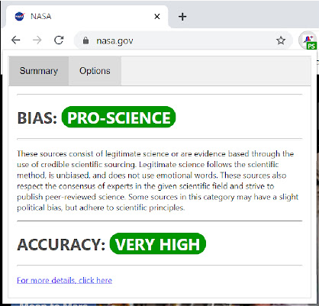

These tags get appended to articles and links to articles on various sites, making it convenient for users to easily tell the nature of the article or content they are going to read.

One method of detecting potential propaganda is the tool called TrustedNews. TrustedNews analyzes word usage within an article to detect whether it is being objective. It is a really good way to determine whether the article is simply reporting an occurrence with all the facts or if they are throwing in their opinion or bias within the mix. Although it may not catch biased undertones, it is effective in detecting more conspicuous bias within an article. The output of the browser extension is an objectivity scale ranging from 1 to 5. 5 meaning that most of the sentences within the specific article are objective. Under the scaling, the tool’s interface displays an overall objectivity percentage which is 66% in the case of the article I clicked on from CNN shown here **[Lans, 2021]**:

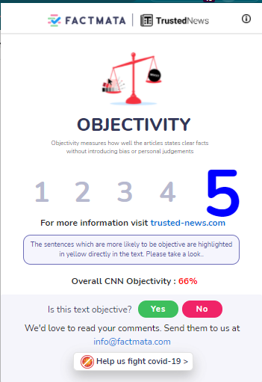

Logically is a browser extension that utilizes artificial intelligence that was a result of collaboration between researchers and expert fact-checkers. This extension takes the analysis a step further by measuring the toxicity of content online. Browsing to Elon Musk’s Twitter page to test the extension. It displayed a toxicity rating of the responses to his tweets in addition to a breakdown of the likelihood of a tweet being toxic with categories like “unsubstantial”, “incoherent”, “likely to reject”, and “other”. The extension even allows you to make your claims about certain information and track the progress of each claim you make. The fact check tab allows you to fact check individual statements or in twitters case individual tweets or responses. The application is probably one of the most sophisticated tools listed and it is only in its beta stage. Here is the percentage it gave me in the use case mentioned**[Lans, 2021]**:

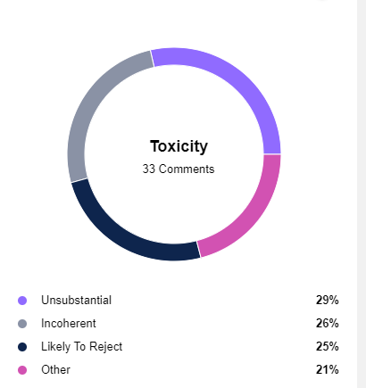

Other than the toxicity rating on platforms like Twitter, viewing the same article on CNN displayed a content analysis indicating source credibility, article credibility, and overall sentiment shown here **[Main, et al, 2021]**:

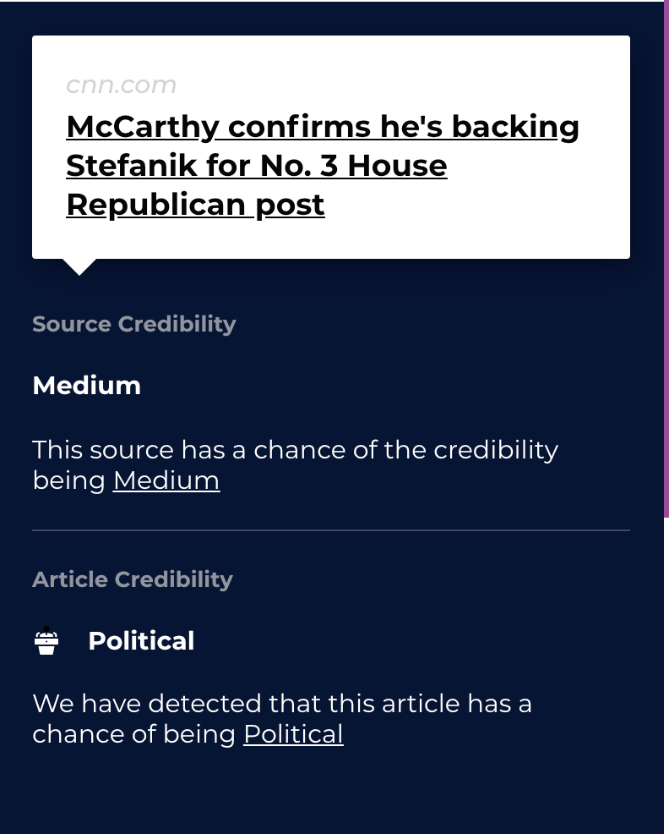

Captainfact stands out from all of the other tools because it is used to analyze videos on platforms like YouTube. Content creators can utilize this tool in their video and users can freely prove or disprove any of the content discussed or shown within the video. This interactive experience is very fitting for video content **[Lans, 2021]**.

**Practicality**

While many people are not aware of this, there is no shortage of tools that aid users in the fight against computational propaganda. The key to the success of these tools at this point is not their usage or functionality, but their awareness of them. While many mainstream media outlets have shed some light on disinformation, it is not nearly enough to make an impact. If it did, then the divisions and misconceptions in today’s world would not be as bad as they are at this point.

So, what could be done to make these more practical for people to use? Can this be integrated into the mobile experience? The tools researched are primarily Google Chrome or browser extensions. Chrome extensions are easy to use, and chrome is the browser of choice for a significant portion of users, whether they use an Apple or Windows computer. However, most people in the world consume information on their smartphones. To make these solutions more practical, it is important to make these tools available in the mobile space and can integrate these tools into their mobile experiences.

There are several ways that these anti-propaganda tools can be implemented on users’ smartphones. One method is utilizing a standalone app that acts as a browser, which may not be that practical for the average person. Another method is chrome allowing extensions on the mobile version of chrome. However, this is still not a feature on the google chrome app. There is an alternate chrome-based browser app called kiwi that allows chrome desktop browser extensions to be installed, but users may not be comfortable using a lesser-known browser and jump through the extra hoop to have a near equivalent experience to using the same extensions on their phones as they would on a desktop or laptop.

The most important obstacle to address is the fact that most users prefer the first-party apps that news outlets and social media platforms develop themselves. We know that specific platforms allow for certain posts to be flagged as false and with the pandemic, platforms generate a banner that links COVID-19 information for anything relating to the virus, but that is as far as it goes. Unfortunately, there are a lot of obstacles to navigate through to make any of the tools widely used. One of the few solutions would be to integrate these tools with first-party applications. This is necessary because people are more likely to use something that is integrated with what they already use. Apple is an organization that does this very well. Over the years they had created a wide variety of native applications that seamlessly integrated within the Apple ecosystem. It is unclear whether a tech giant like Apple or Google would integrate a tool within their systems. The only way to get more users to utilize tools to fight fakes news would be to make these tools more popular, there is always the possibility of a tech company implementing one as a result. There is also the possibility that these companies may not wish this for their users. Unless there is an imminent financial threat to large companies, it may be very difficult for them to implement a tool like this. However, if an effective tool proves to be financially beneficial, then it is likely they may implement a tool like this. Apple may be the tech giant that should implement a misinformation tool in their safari browser and iOS versions of their social media apps. They are one of the companies that have demonstrated that they care for the privacy of their users’ information more than other companies. Giving users the option to not give information to Google. Facebook, and other companies known to collect user data.

**Application Overview**

The tools explored and discussed contribute much to the battle against disinformation and fake news. However, there should always be new approaches devised to indicate disinformation. Many of these tools utilize similar concepts to determine whether the information a user is viewing is credible. One method that may have not been explored as much is providing insight on readers that are viewing articles and social media posts online. If a reader knew where other readers viewing the same article or post as they were from, how would they feel about that information? Would it cause them to feel more negative or positive about the information? Would they be more or less likely to believe what they are viewing? This is the approach I want to take with the tool I will create, to give other users more insight into the information they consume. This may be the key to allow users to think more critically about what they view. Questions that they may ask themselves could be the following. “Am I in an echo chamber?”, “Am I just reading and sharing information I agree with?” How true is the information I ingest and spread daily?”, “How credible are the resources I rely on?”

The information provided would be the following; where the users are from (northeast, south, west coast, etc.), what their political standing is based on location. In other words, what the majority political standing of that location is from. Their age is another factor that will be included, as there are generational differences in the way people think. This may also be based on location, since younger people may be more likely to reside in more urbanized areas, etc. A variable that will be called an average propaganda score will be included. This will rate the average propaganda intake of the readers viewing the article. For example, people who view fringe sites like info wars are more likely to have a high propaganda score as opposed to someone who regularly reads the Associated Press. These factors are important in allowing a reader more insight into the information that they are consuming. This is what will sharpen the minds of individuals online and allow them to be better at distinguishing between reality and falsehood. The goal that all academics and researchers want to attain with their findings and tools that they had created.

This tool will be in the form of a chrome extension ideally or in the form of a web application run in a browser. The graphical interface will display average ages and location in a clear and concise visualization. It may be in the form of a meter or simple numeric form. A pie chart may be the best way to view percentages of users from political affiliations that something like this pie chart but the percentage of which person of which party or political leaning such as right-wing, left-wing, centrist, etc. is viewing a given article or post **[Wikimedia 2021]**:

This along with the additional variables mentioned previously would give readers an easy-to-understand overview of the other readers who are viewing this article and help readers ponder upon this information. A rough concept of how it would appear to a user would be the following. 45% percent of users from the northeast who are left leaning between the ages of 25 to 35 with a propaganda score of 0.2 are viewing this article.

This information would give a reader a good idea of what the reader base of the content they are viewing is and can give them insight into whether people who view the information in question stand on the political spectrum as well as whether they are more likely to view information that has a particular agenda. Sometimes this can be seen by the political leaning, but this will mostly depend on the propaganda rating provided by the tool when viewing a page. The political leaning may also include more categories than right, left, or centrist. It may also include categories like a far-left, far-right, conspiracy theorist, and so on. The more categories, the more a user could benefit from the information provided. However, it may be better to simplify the categorizations for the sake of usability. All this information would be displayed to a user when viewing a given article or post.

While this is a different approach in displaying insight on information online, this concept will open new avenues to how we can provide insight on the information that we view online. This approach is very possible for many platforms to implement. Since data collection has been a hot topic in recent years, this may be a way for platforms to use the data they collect in a potentially positive way. While many debate the ethics of personal data collection, showing the data they collect back to their users in a meaningful way. This can be done in the same way proposed in the tool and will be much easier for tech platforms to do since they already have all the data, they need to do this.

**Browser Extension Implementation**

I have developed a chrome extension that simulates the concepts that I had mentioned previously. This extension displays an average propaganda score from a scale of 1 to 10 the higher the propaganda score, the more propaganda other users viewing the same page as you have been frequenting here is how it looks:

Webapps and chrome extensions differ greatly in capability and functionality. You cannot build a chrome extension like a traditional webapp with a frontend and backend. The purpose of a chrome extension is meant to run on top of web pages and interact with them. I needed to figure out how to pull information from a user data csv I had created to simulate actual user data being pulled and displayed in a meaningful form. I had achieved this by utilizing APIS and manipulating the JSON objects within the API to present it properly.

After uploading my custom user dataset into the opensource CSV API, Retool, I was able to call the API by each individual row. To return an average propaganda score from a collection of users from the dataset. I accomplished this by doing five separate API calls that return a random row number from the dataset between 1 and 25 (this was the number of rows/users from my dataset), push those score values to an array and average them after the fifth call. The result is then shown and depending on how high the score is, the score will have a warmer color, with Indicators that say “LOW”, ”CAUTION”, ”ELEVATED”, and “HIGH” depending on how high the number is.

The second tab uses the geolocation function in JavaScript in conjunction with the google maps API to display your current location in a small google maps window:

Third tab called “Polistats” takes the users coordinates which are then plugged into the Google Geocoding API call which returns very detailed information about your location, including State, City, and even street address. A conditional statement is put in place to see which state the user is from and return political demographic information of that state. This was achieved by taking a dataset from Pew research that listed the percentage of each political ideology from each state, converting it to a CSV and using retool to create another API for this political dataset. This allowed me to extract the and use the data as intended:

The intent is to provide users insight into the reading habits of other users viewing the same pages as them. An insight that is not often given to users. In addition, allowing them to cross-reference that with the political demographics. This would allow them to see a correlation or lack thereof between their user’s propaganda score and their political beliefs.

**Difficulties in Development**

There were a lot of bumps and learning curves that had to be overcome while developing this application. With little experience in coding JavaScript and no knowledge of how extensions were created, it took quite some time to put this together in a meaningful form with the time constraint in consideration as well. Webapps and browser extensions differ in functionality and capability. Webapps have a wide range of capability and complexity with a frontend and a backend. Browser extensions are lightweight apps meant to run on top of a webpage and are meant to run on top of a webpage and interact with it in addition with other miscellaneous features.

Understanding this key difference was what enabled the ability to develop an extension to function as intended. I initially tested the extension as a webapp before loading it into my browser as an extension and everything initially worked fine. However, there are security measures put in place in the extension’s manifest file that must be addressed. The manifest file is a JSON header file of an extension with a variety of parameters, without this file being configured properly, the extension would not load properly or even at all, this was perhaps the biggest difficulty aside from utilizing API calls as intended.

**Conclusion**

Disinformation is the new enemy we must combat to prevent any more conflict that could result from it. Many instances should push more people to take disinformation more easily. In the early days of social media, our teachers and parents would always tell us not to believe everything we read on the internet. Now, with the internet being an ocean of knowledge that many people rely on for research, communication, and news.

With many now aware that fake news is on the rise we have completed the first step in combatting it, now we must show users that there are easy-to-use methods available for them to use when traversing the internet. The methods currently available have proven effective in the diverse approaches they take and have given researchers and journalists a new frontier for them to explore. Given some time, more findings will continually create new methods of detection and prevention of fake news. However, all this research, findings, and tools will go to waste if they do not benefit the lives of everyday individuals.

More than enough research has been done to demonstrate the consequences of disinformation and enough has been done to devise tools that have proven effective against it. The final step is to continually improve these tools and increase their use so that a good portion of the population uses and benefits from them.

**References**

1. A. (2016, March 22). 11.2 the evolution of the internet. Retrieved May 04, 2021, from <https://open.lib.umn.edu/mediaandculture/chapter/11-2-the-evolution-of-the-internet/>
2. Vorhaus, M. (2020, June 25). People increasingly turn to social media for news. Retrieved May 05, 2021, from <https://www.forbes.com/sites/mikevorhaus/2020/06/24/people-increasingly-turn-to-social-media-for-news/?sh=27bab7d23bcc>
3. Frank, A. (2018, February 09). Computational propaganda: Bots, targeting, and the future. Retrieved May 02, 2021, from <https://www.npr.org/sections/13.7/2018/02/09/584514805/computational-propaganda-yeah-that-s-a-thing-now>
4. Suciu, P. (2019, October 31). Does social media make the political divide worse? Retrieved May 02, 2021, from <https://www.forbes.com/sites/petersuciu/2019/10/30/does-social-media-make-the-political-divide-worse/?sh=392fcfdf6e3a>
5. Alexander Smith and Vladimir Banic. 2016. Fake news: How a partying Macedonian teen earns thousands publishing lies. NBC News 9 (2016). Available at https://www.nbcnews.com/news/world/fake-news-how-partying-macedonian-teen- earns- thousands- publishing- lies- n692451.
6. Victoria L. Rubin. 2010. On deception and deception detection: Content analysis of computer-mediated stated beliefs. Proceedings of the Association for Information Science and Technology 47, 1 (2010), 1–10.
7. Xinyi Zhou and Reza Zafarani. 2020. A Survey of Fake News: Fundamental Theories, Detection Methods, and Opportunities. ACM Comput. Surv. 53, 5, Article 109 (September 2020), 40 pages. <https://doi.org/10.1145/3395046>
8. YouGov. 2017. C4 study reveals only 4% surveyed can identify true or fake news. Retrieved from <http://www.channel4.com/info/press/news/c4-study-reveals-only-4-surveyed-can-identify-true-or-fake-news>
9. Kathleen Hall Jamieson and Joseph N. Cappella. 2008. Echo Chamber: Rush Limbaugh and the Conservative Media Establishment. Oxford University Press.
10. Lynch, S. N. (2021, August 1). *U.S. will not lock down despite Surge driven by delta Variant, Fauci says*. Reuters. <https://www.reuters.com/world/us/fauci-predicts-us-will-not-return-lockdowns-despite-delta-variant-risks-2021-08-01/>.
11. Hui, P.-M., Yang, K.-C., Torres-Lugo, C., & Menczer, F. (2020). BotSlayer: DIY Real-Time Influence Campaign Detection. *Proceedings of the International AAAI Conference on Web and Social Media*, *14*(1), 980-982. Retrieved from <https://ojs.aaai.org/index.php/ICWSM/article/view/7370>
12. Oshikawa, R., Qian, J., & Wang, W. Y. (2020, March 5). *A survey on natural language processing for fake news detection*. arXiv.org. https://arxiv.org/abs/1811.00770.
13. Lans, S. (2021, March 18). 12 browser extensions to help you detect and avoid fake news. Retrieved May 02, 2021, from <https://thetrustedweb.org/browser-extensions-to-detect-and-avoid-fake-news/>
14. Main, A., & Robertson, N. (2021, May 09). McCarthy confirms he's backing STEFANIK for No. 3 House Republican post. Retrieved May 11, 2021, from <https://www.cnn.com/2021/05/09/politics/kevin-mccarthy-elise-stefanik-liz-cheney-replacement/index.html>
15. Lang, F. (2019, September 30). Social media plays a huge role in disinformation campaigns. Retrieved May 04, 2021, from <https://interestingengineering.com/social-media-plays-a-huge-role-in-disinformation-campaigns-with-70-countries-on-the-list>
16. File: U.S. *party AFFILIATION.SVG*. Wikimedia Commons. (n.d.). <https://commons.wikimedia.org/wiki/File:U.S._party_affiliation.svg>.
17. P. Research, “Religion in America: U.S. religious data, Demographics and statistics,” Pew Research Center's Religion &amp; Public Life Project, 09-Sep-2020. [Online]. Available: <https://www.pewforum.org/religious-landscape-study/compare/political-ideology/by/state/among/party-affiliation/democrat-lean-dem/>. [Accessed: 08-Dec-2021].
18. P. Research, “Religion in America: U.S. religious data, Demographics and statistics (Kansas),” Pew Research Center's Religion &amp; Public Life Project, 09-Sep-2020. [Online]. Available: <https://www.pewforum.org/religious-landscape-study/state/kansas/political-ideology/>.[Accessed: 08-Dec-2021].
19. P. Research, “Religion in America: U.S. religious data, Demographics and statistics (Wyoming),” Pew Research Center's Religion &amp; Public Life Project, 09-Sep-2020. [Online]. Available: <https://www.pewforum.org/religious-landscape-study/state/wyoming/political-ideology/>. [Accessed: 08-Dec-2021].
20. J. Rocheleau, “9 simple CSS &amp; JS snippets for creating beautiful tabs,” Speckyboy Design Magazine, 05-Dec-2021. [Online]. Available: <https://speckyboy.com/10-simple-code-snippets-creating-beautiful-tabs/>. [Accessed: 08-Dec-2021].